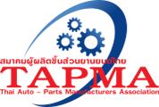
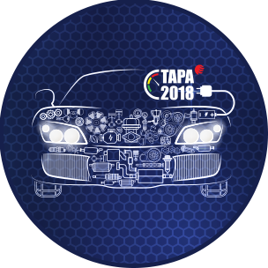

Reply Sheet
Seminar Program
Special Forum on “Auto Parts industry in Eastern Economic Corridor (EEC)”
BITEC, Bangna, Bangkok, Thailand
*Free registration and in English language

Organization/Company : ………………………………………………………………..

Address : ………………………………………………………………..

………………………………………………………………..

Business Title : ………………………………………………………………..

- Name : ………………………………………………………………..
Division/Department : ………………………………………………………………..
Telephone : ………………………………………………………………..
E-mail Address : ………………………………………………………………..

- Name : ………………………………………………………………..
Division/Department : ………………………………………………………………..
Telephone : ………………………………………………………………..
E-mail Address : ………………………………………………………………..

- Name : ………………………………………………………………..
Division/Department : ………………………………………………………………..
Telephone : ………………………………………………………………..
E-mail Address : ………………………………………………………………..

- Name : ………………………………………………………………..
Division/Department : ………………………………………………………………..
Telephone : ………………………………………………………………..
E-mail Address : ………………………………………………………………..

- Name : ………………………………………………………………..
Division/Department : ………………………………………………………………..
Telephone : ………………………………………………………………..
E-mail Address : ………………………………………………………………..

Please confirm your attendance to
Ms. Wankanit Nintawong, Thai Auto-Parts Manufacturers Association (TAPMA)
Tel: (66) 61-959-1625, (66) 2-286-9166 to 167
Fax: (66) 2-286-9168 to 169
Email: wankanit@thaiautoparts.or.th , wankanit.tapma@gmail.com

